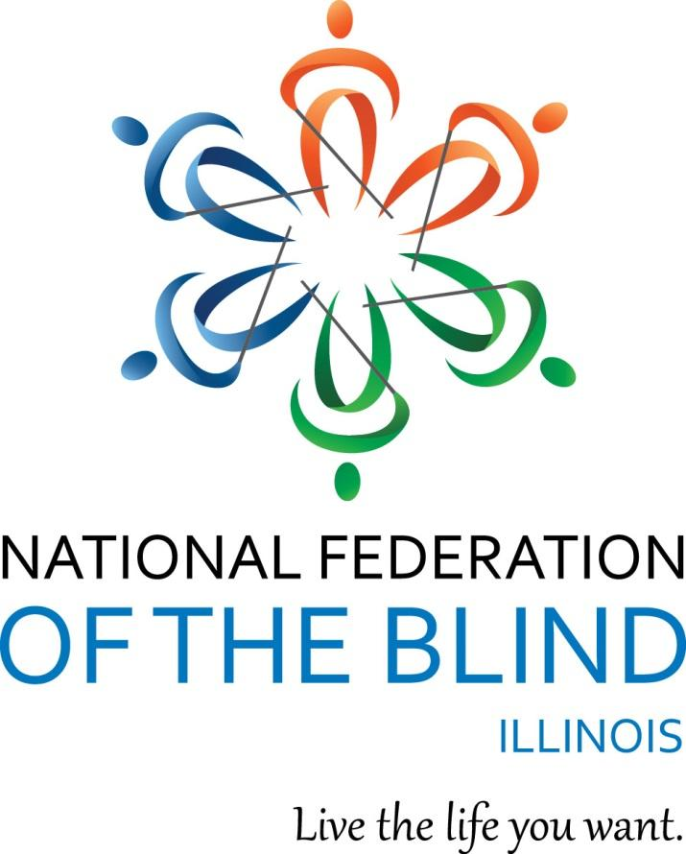

National Federation of the Blind of Illinois

State Convention 2025
“Reflecting our Truth”

AGENDA
NATIONAL FEDERATION OF THE BLIND
OF ILLINOIS
Annual Convention
October 17-19, 2025
Naperville Marriott
1801 Naper Blvd
Naperville, IL 60563
630 505-4900
Naperville Marriott Website

The National Federation of the Blind of Illinois is thankful to our 2025 state convention sponsors.

Gold Level Sponsors:
Friedman Place

https://www.friedmanplace.com

Vanda Pharmaceuticals
https://vandapharma.com

Members of NFBI wish to thank the following donors for their generous gifts:
The Aileen S. Andrew Foundation
Illinois Prairie Community Foundation Inc.
Community Fund Quad Cities Mildred Crespin-Croegaert Fund
Mr. Harold W. Knapheide III, in honor of his mother, the late Mary MacDill Knapheide
The Trinity Fellowship Church
Episcopal Church Women
The Naperville Noon Lion's Club
Chapin Lions Club
Frankfort Lions Club
The Chicago Lighthouse
Richard Lansden and Roger Hickman, Trustees, The Leona Stanford Vollintine Charitable Trust
Baptist foundation of Illinois in memory of Richard V and Annette R. Grove
Multiple donors in memory of Helen Avant
Linda Villa in memory of her late husband, George Villa
St. Rafael Knights of Columbus Council 14171 in memory of George Villa
Illinois Association of Blind Merchants, a division of the National Federation of the Blind of Illinois
NFBI Chicago chapter, a chapter of the National Federation of the Blind of Illinois
NFBI At Large chapter, a chapter of the National Federation of the Blind of Illinois

Logistics: Announcements, Registration, Information Desk, and Smoking Policy

Announcements that you wish to be made from the convention floor during sessions MUST be submitted to the information desk in the convention hall. Mary Grunwald and Jean Johnson are coordinating our information desk this year. Michal Nowicki and Kira O’Bradovich are handling the registration table at the convention. Tasabih Elfaki and Michelle Ault are running our door prize table.
If you wish to reach President Marilyn Green during sessions, please text 312-343-8396.
Smoking is not permitted in convention sessions.

Marilyn Green, President
National Federation of the Blind of Illinois (NFBI)
5128 N. Oak Park Ave.
Chicago, IL 60656
(312) 343-8396
NFBI Website
National Federation of the Blind Website

2025 Naperville Marriott Hotel/Convention Information
Naperville Marriott Website
This quick article explains the layout of the Naperville Marriott which is our convention hotel for 2025. It also gives you basic information about the facilities and amenities.

Address and Phone:
The hotel is located at 1801 N. Naper Blvd Naperville, IL 60563. The phone is: (630) 505-4900.

Sleeping Room Types:
There are two types of rooms. A Suite and a Standard Room. The suites have a parlor with a sleeper sofa and two easy chairs. The room rate for 1 King bed is $142 and the room rate for 2 Queen beds is $152 per night. All rooms have hair dryers and coffee makers. Connecting rooms are available upon request.

Key cards and Electrical Power:
This hotel is modernized. You need to insert your keycard in a slot inside your room to the side of the door to turn your power on. Leave it in the slot until you exit your room. When you remove it, the power goes off again.

Checkout:
Check in time is 3:00 p.m. Checkout time is 12:00 p.m.

Wi Fi:
There is free Wi-Fi in all lobbies and common areas. This includes our meeting rooms.

Facilities and Amenities:
There is an indoor pool, fitness room, and jacuzzi. There is lots of parking, especially at the side door.

Layout:
If you enter through the main doors, the layout is as follows: the Starbucks is to the left. You should walk ahead to where the tiled flooring forms a cross. If you turn left at the "lobby cross" with the doors at your back, you can enter Starbucks by taking the first left. If you take a right, you can go to the elevator bank. If you pass the elevators, you head toward the meeting rooms.
From the front door, if you bypass the crossing of the tiled portions of the lobby and keep going straight, you will find our information desk on your left and the hotel desk on your right. If you pass both, there is a restaurant directly ahead. You can find the bar, which also serves food from the restaurant, by going left after passing the hotel desk. The bar will be on your right, although people can also sit on the left side at this point.
At this point, it is easier if you reorient to the lobby desk. If you are standing facing the hotel front desk, the elevator bank is down the tiled hall to the right of the front desk. There are three elevators on your left side down that hall a short way. They are fast.
Our meeting rooms are laid out past the elevator bank. Right after the elevators there is a cash machine on your left and restrooms on your right. Past those, first you come to a hallway where conference rooms A, B, and C are on your left headed away from the lobby. Conference rooms D, E, and F are on your right. Past that Hall the hall divides at a Y. There is another set of restrooms down by the other conference rooms near Bailey. If you go left, you come to Bailey-Hobson and if you go right you will get to the Naper Ballroom. We are in the Naper Ballroom for all general sessions, the luncheon, the banquet and both breakfast sessions. Outside of the Naper Ballroom we will have exhibits and we will have our registration.
There is a dog relief area outside of the Naper room. Exit and walk a short way, then take a 45-degree left turn. There is a cement patio area on the left about 30 ft. up. At the end of the patio, you will find a grassy area with trees which will work well for dog relief. There is even a hydrant.

Braille is Beautiful - Friday
Braille is Beautiful will take place on Friday. Please feel free to reach out to Debbie Stein if you wish to participate.

Set-up for Naper Ballroom
When you enter the Naper Room it is wider left to right and shorter going ahead from the doors. You enter at the back of the room. We will have info, sales, and PAC in the back of the room and the head table/stage will be furthest from the doors by the windows. The door prize table will be on the left as you face the stage.

INFORMATION, PAC AND SALES TABLES
The information desk will be in the hotel main lobby on Friday, Oct. 17 from 2:00pm to 4:30 p.m., and in our general session room during general sessions. Registration will be in the hallway outside of the Naper room on Friday from 2:00pm to 5:00 p.m. as well as on Saturday from 8:00 a.m. to 9:00 a.m. The sales table will be in the back during general sessions. The PAC plan table will also be in the back during general sessions. Exhibitors will be outside of our general session room.

Announcements:
Masks are optional at our convention. If attendees wish to wear a mask, they may feel free to do so. The National Federation of the Blind of Illinois will follow the convention hotel’s policies. We will additionally follow any guidelines mandated by the Centers for Disease Control (CDC) and local, state, or federal entities that may be enacted up until the close of our convention. Note that this statement is subject to change based on hotel policy, local, state, or federal regulations that may be placed in effect at the time of our convention.
The National Federation of the Blind of Illinois fosters a safe and inclusive environment for all at our events and meetings. We ask that you refrain from wearing or using excessive fragrances, including perfumes, colognes, and scented personal care products. Some people may have allergies to fragrances, the effects of which may be dangerous. Thank you for maintaining a safe and inclusive environment for all.
A cash bar will be staffed for our Friday night NFBI’S Got Talent and our Saturday night banquet. Please bring cash if you would like to enjoy an evening beverage.
You can help build a future of opportunity for the blind by becoming a member of our Dream Makers Circle. Your legacy gift to the National Federation of the Blind or the National Federation of the Blind of Illinois can be made in the form of a will, or living trust, an income generating gift, or by naming us as the beneficiary of a life insurance policy. For additional information, please contact Patti Chang at (773) 307-6440 or at pchang@nfb.org.
The PAC Plan allows members, affiliates, chapters, and others to give a regular and automatic donation to the Federation every month. All you need to provide is your checking, savings, or credit card account identification information.
Because of the costs associated with operating the program, the minimum donation is $5 a month and there is no restriction on how much you donate.
Please sign up at the PAC table during convention to begin a new PAC contribution or to make changes to your current contribution. Your donation will help the blind live the lives they want.
In lieu of a kid's camp, the National Federation of the Blind of Illinois will provide a kid’s playroom at the state convention. The playroom, Conference Room F, will be open during all general sessions and the banquet. The playroom will have toys and art supplies and all activities must be supervised by an adult. The National Federation of the Blind of Illinois will not be staffing the playroom and assumes no liability.

Welcome to our 2025 State Convention of the National Federation of the Blind of Illinois!!! Have a great convention, everyone!!

Friday, October 17, 2025, Afternoon
2:00-5:00 Exhibits - Hallway outside of Naper Ballroom
American Blind Skiing Foundation
Blind Professionals Network
En-Vision America
Illinois ABLE
Illinois Division of Rehabilitation Services/ Bureau of Engagement and Support Services
Magic Glove
Vanda Pharmaceuticals
visualEyes Access

2:00-3:30 Sculpting with Clay – Ralph Cossentino, Instructor of Figurative Sculpture at the Palette and Chisel in Chicago, Naper Ballroom

2:30-3:30 Relaxation Sound Bath with Busy Body Retreats– Anna Romo, Founder, Busy Body Retreats LLC, Conference Room C

2:00-4:30 Information Table – Mary Grunwald and Jean Johnson, Hotel Lobby
2:00-6:00 Registration, Michal Nowicki, NFBI Treasurer and Kira O’Bradovich, NFBI Chicago chapter Treasurer
Hallway Outside of Naper Ballroom
4:00-5:00 Resolutions – Michal Nowicki and Dustin Cather, Co-Chairs NFBI Resolutions Committee
Naper Ballroom

Friday, October 17, 2025, Evening
5:00-7:00 General Membership Dinner and evening general session-
Cost $20, Naper Ballroom
5:00-5:10 Welcome and Announcements – Marilyn Green, President NFBI
Pledge of Allegiance
Moment of Silence, Dan Dwyer– January 16,1957 to June 30, 2024- Chicago Chapter

5:10-5:30 Dinner
5:30-6:15 Braille is Beautiful
6:15-6:30 Meet the 2025 State Scholarship Class-David Meyer, 2025 State scholarship chair, National Federation of the Blind of Illinois
7:00-11:00 NFBI’S Got Talent- Admission $5, includes your first performance
Michelle Ault, NFBI Chicago chapter Board Member and Tasabih
“Abbu” Elfaki, NFBI Board Member, Naper Ballroom
Join us for the National Federation of the Blind of Illinois’ Got Talent
Based on the popular TV show, America’s Got Talent. NFBI’s Got Talent invites everyone to participate as a soloist or group and perform a song of their choice. Bring an instrument and perform your favorite song. Each performance costs $5 per person. Don't forget our “Battle of the Chapters.” This year's theme is TV theme songs.

Saturday, October 18, 2025, Morning

Reflecting our Truth Breakfast, Naper Ballroom

7:00-7:10 Introductions
7:10-7:30 Breakfast Served
7:30-8:10 The National Federation of the Blind: Our Truth is Our History– Peggy Chong, The Blind History Lady
8:10-8:20 NFB Resolutions: Our Truth is in Our Policy–Donald Porterfield, Resolutions Committee Chair, National Federation of the Blind
8:20-8:30 The Truth about Structured Discovery: A Summary–Amy Porterfield, President, Saavi Services for the Blind and Tristan Ratliff, Program & Operations coordinator, Minnesota Center for the Blind

8:00 - 9:00 Registration
Michal Nowicki, NFBI Treasurer and Kira O’Bradovich, NFBI Chicago chapter, Treasurer
Outside of Naper Ballroom
Later registration, see Michal Nowicki in General Sessions

8:00 - 11:00 Exhibit Hall
Outside of Naper Ballroom

Visit our 2025 state convention exhibitors. This will be our final opportunity to browse the hall and access their products, programs, and services.

9:00-11:30 Breakouts

Breakout 1
9:00-10:00 Structured Discovery: Demystified, Amy Porterfield, President, Saavi Services for the Blind and Tristan Ratliff, Program & Operations Coordinator, Minnesota Center for the Blind

Breakout 2
9:00-10:00 Illinois Association of Blind Merchants Division meeting
Ed Birmingham, President, Illinois Association of Blind Merchants

Breakout 3
10:20-11:30 Fearless Flights Breakout
Breeanna Douglas, Chapter President, National Federation of the Blind of New Jersey

Breakout 4
10:20-11:30 Parent Breakout
Deborah Kent Stein, Secretary, National Federation of the Blind of Illinois and Illinois NFB BELL coordinator

11:30-12:00 Break

12:00-2:30 General Session
Naper Ballroom
12:00-12:05 Welcome and Announcements – Marilyn Green, President NFBI
12:05-12:25 Lunch Served
12:25-1:10 National Report – Donald Porterfield, National Board Member, National Federation of the Blind; National Rep., National Federation of the Blind
1:10-1:25 An Update from the Illinois Bureau of Customer & Community Blind Services–Andrew Webb, Bureau Chief, Customer & Community Blind Services
1:25-1:35 2025 NFB BELL & NFB STEM2U: the Student Perspective– Debbie Stein, Illinois NFB BELL Coordinator; Bridget Hickey, Lead Teacher, Illinois NFB BELL Chicago; Alaula Sprecher, Illinois NFB STEM2U Coordinator; and the NFB BELL &NFB STEM2U students
1:35-1:50 2025 NFB State and National Scholarship Programs– David Meyer, 2025 State Scholarship Committee Chair, National Federation of the Blind of Illinois
1:50-2:05 The Minnesota Center for the Blind, formerly Blind Inc.– Tristan Ratliff, Program & Operations Coordinator, Minnesota Center for the Blind
2:05-2:15 2025 Washington Seminar & the NFB Legislative Priorities-Denise Avant and Dustin Cather, 2025 Federal Legislation co-chairs, National Federation of the Blind of Illinois
2:15-2:30 What is an ABLE account-Stephanie Kanter, Director, Illinois ABLE
2:30-3:00 Break

Saturday, October 18, 2025, Afternoon continued

3:00-5:00 General Session, Naper Ballroom

3:00-3:05 Call to Order
3:05-3:20 The Bay Bridge Run and Other Ways to Give– Patti Chang, Director of
Outreach for The National Federation of the Blind
3:20-3:30 Closing Remarks – Donald Porterfield, NFB National Representative
3:30-4:00 State Reports
Treasury Report – Michal Nowicki, Treasurer, National Federation of the Blind of Illinois
Presidents Report – Marilyn Green, President, National Federation of the Blind of Illinois
4:00-4:30 Resolutions – Michal Nowicki and Dustin Cather, Co-chairs
4:30-5:00 Elections
General Board Seats
Board Seat 1 Currently Held by Sara Luna
Board Seat 2 Currently Held by Tasabih Elfaki
Board Seat 3 Currently held by Steve Hastalis
Board Seat 4 Currently Held by Dustin Cather

Election of Delegate and Alternates to 2026
National Convention

5:00 Adjourned

Saturday, October 18, 2025 Evening

5:20-5:50 Scholarship Committee Meeting – President’s Room

6:00-7:00 Hospitality – Fourier Outside of Naper Ballroom

Annual Banquet -Naper Ballroom
MC – Denise Avant, 1st Vice President
National Federation of the Blind of Illinois
7:05-7:10 Welcome and Invocation – Eileen Truschke, Member, National Federation of the Blind of Illinois, Chicago chapter
7:15-7:45 Dinner
7:45-7:55 How We Reflect our Truth: Museum of the Blind People’s Movement-Patti Chang, Director of Outreach, National Federation of the Blind
7:45-8:00 Fifteen for Funds – Cathy Randall, Board member, National Federation of the Blind of Illinois
8:00-8:30 Banquet Speech – Donald Porterfield, NFB National Representative
8:30-8:45 Scholarship Awards – David Meyer, 2025 Scholarship chair, National Federation of the Blind of Illinois
8:45 Adjourned

9:00-11:00 Hospitality

Sunday, October 19, 2025, Morning

8:00-10:00 Scholarship/General Membership Breakfast–
Naper Ballroom

Thank you for all you do!
Thanks to the Special Events Committee, the Sound committee, and all others who have served on committees, worked registration and information tables, secured door prizes, and appeared on the agenda. You have helped make this convention a tremendous success.

NFB PLEDGE
I pledge to participate actively in the efforts of the National Federation of the Blind to achieve equality, opportunity, and security for the blind, to support the policies and programs of the Federation, and to abide by its constitution.

BELIEF MESSAGE
The National Federation of the Blind advances the lives of its’ members and all blind people in the United States. We know that blindness is not the characteristic that defines you or your future. Every day we raise the expectations of blind people because low expectations create obstacles between blind people and our dreams. Our collective power, determination, and diversity achieve the aspirations of all blind people.

